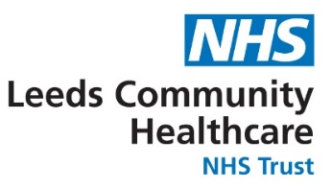**Gender Pay Gap Reporting**

**Assurance and Supporting Statements**

Leeds Community Healthcare NHS Trust fully supports gender pay gap reporting across both private and public sector organisations. The Trust is fully committed to equality of opportunity within our workforce and recognises the societal issues facing women in the workforce and the long-term focus required to address the gender pay gap. Gender equality is part of our overall diversity and inclusion workstreams, to ensure that the workforce is representative of the communities we serve.

Historically the structure of medical careers was designed originally for a predominantly male workforce, with the expectation of full-time work for a long career and an ability to take on extra commitments. This has resulted in a lower average salary for the female workforce. The pay gap is not due the fact that we pay men and women differently for the same work but that we have lower numbers of men in lower paid jobs and more women in these roles and fewer in higher paid roles

There has been a reduction in the both the Mean (3.5%) and Median (-1.8%) GPG, due to percentage decrease in Female representation in both Quartiles 1 and 2, and the percentage increase of Female representation in Quartile 3.

Furthermore, the Gender Bonus Pay Gap (GBPG) (Mean) within LCH is -16% in favour of females. The GBPG (Median) remains at 0%.

Our Gender Pay Gap actions are listed below,

We will continue to

* Promote local, regional, and national development and networking opportunities for women.
* Use skill-based assessment tasks in recruitment
* Use structured interviews for recruitment and promotions
* Ensure all of LCH promotion, pay and reward processes are transparent
* Promote the Trusts flexible working policy for men and women
* Encourage the uptake of Shared Parental Leave - The gender pay gap widens dramatically after women have children, but this could be reduced if men and women were able to share childcare more equally, we will continue to work with the Men’s Health Forum to raise awareness and increase uptake

The data has been drawn directly from our financial records and the payroll system. The information has been analysed using the NHS national gender pay gap business intelligence reporting programme produced by the national Electronic Staff Records (ESR) team. This therefore provides assurance on the data gathering and analysis process and the controls to support the data quality within this report.



Jenny Allen & Laura Smith

Director of Workforce, OD & System Development

Leeds Community Healthcare NHS Trust